PRESS RELEASE JDN115

NEW CONCEPT STANDARDIZES HOIST & CRANE CONTROL

J D Neuhaus (JDN) has developed an innovative and robust new concept for controlling hoists and cranes. The company’s JDN-RC (Radio Control) receiver is designed for long-lasting performance in rigorous operating environments commonly found in industrial and offshore applications, including ATEX (explosive atmosphere) zone 2/22 conditions.

Featuring a solid and extremely compact receiver (w = 250 mm, d = 120 mm, h = 200 mm) to suit even hoists with low-carrying capacity, all components are accommodated in a shock-resistant GRP casing offering protection class IP65. This means that the device is totally protected against the ingress of dust, and can withstand low-pressure water jets from any direction, thus making it resistant to seawater in offshore applications. Breathable membranes are deployed to help guide any condensation from the interior to the exterior.

The meticulously-designed device facilitates quick and straightforward installation. This is largely because the JDN-RC has been developed to help standardize hoist and crane control. As a result, the receiver can be mounted on the hoist or trolley, or at a separate location, in line with specific customer requirements. What’s more, the standardized interface on the JDN-RC means it can be offered as a retrofit solution for JDN’s existing product range, e.g. their industry-leading Profi air operated hoists.

Continued ……
At the transmitter, single or two-step commands are supported by control elements that include a key switch, start and stop buttons, joystick, LED operating status display and LED low-voltage indicator. The JDN-RC control allows users to work at a safe distance from the load and take a better viewpoint during operations. Here, the signal and selected command is transmitted and transferred into the controls of the crane or hoist by the receiver to ensure instantaneous performance.

Ultimately, the JDN-RC is ideal for spanning long distances between the hoist and the operator, and represents a sensible alternative to applications demanding a long control hose. The design also facilitates use in hard-to-access locations, while multiple hoists can be controlled simultaneously if required. A charger for the external battery and a leather strap are supplied with every unit.

Both the transmitter and control receiver are rated for operation within the toughest of working conditions and are insensitive to dust and humidity. The transmitter has a working temperature range of -20 to +55°C whilst the receiver operates within a -25 to +55°C range. A transmitter Ex classification is provided of Ex II 3G Ex ic IIB T4 Gc and Ex II 3D Ex ic IIIC T95° C Dc for zones 2 and 22 respectively and Ex II 3G Ex nc [ic] IIB T4 Gc (zone 2) Ex II 3D Ex tc [ic] IIIC T135° C Dc (zone 22) for the receiver.

With over 200 employees across the group, J D Neuhaus manufactures pneumatically and hydraulically-operated hoists and crane systems up to 115 metric ton capacity from its state-of-the-art facility in Witten, Germany. This globally unique specialization means that J D Neuhaus has set the quality standard for the market, a move that has seen the company become the established global leader in its technology field with customers in more than 90 countries worldwide.

Resilience and reliability are the key product differentiators, thanks largely to their explosion protection rating which makes them ideal for use even in the most challenging of operating environments. Extreme applications include oil and gas exploration in arctic temperatures as low as -45°C, along with underwater tasks such as ship hull repairs, and plenty of others in demanding sectors like mining, the chemical industry, heavy plant construction and many areas of logistics.
Continued ……
The wide portfolio of services provided by J D Neuhaus includes equipment assembly, inspection, maintenance and general overhaul, along with the supply of customer training courses. Over 80% of production from the Witten plant is exported, which is why the company has long-established subsidiary companies in France, Great Britain, Singapore and the USA, all of which have helped create a tight-knit global network in collaboration with international partners.

J D Neuhaus has history that can be traced back to 1745, and is now in its seventh generation of family ownership. Visitors to the Hebezeug-Museum (Hoist Museum) in Witten, are able to see for themselves the remarkable history of this progressive company.

Further information is available on request to:
J D Neuhaus L.P., 9 Loveton Circle, MD 21152 Sparks, USA
Contact: Peggy Weber e-mail: p.weber@jdneuhaus.com
Office Phone: 1-888- NEUHAUS www.jdngroup.com

Worldwide contact details for J D Neuhaus can be seen at the end of this press release.

facebook.com/jdneuhaus twitter.com/JD_Neuhaus

(approximately 740 words
including photographic annotations)
General Information

Supplier: J D Neuhaus L.P.

Press Release No: JDN115

Press or publishing inquiries to: Steve Lloyd
Enterprise Marketing Services Ltd
The Coach House, 1 Dunstall Road, Barton under Needwood,
Burton on Trent, Staffordshire, DE13 8AX, UK
Tel: +44 (0) 1283 713185
Fax: +44 (0) 1283 716172
e-mail: info@enterprise-marketing.co.uk

Reader response inquiries to: Ms Peggy Weber of J D Neuhaus L.P.

Downloads: The press release text (MS Word and PDF format) and images are
available for download at:

www.enterprise-marketing.co.uk/jdn/jdn115.html

Our Reference: JDN115/17/04/V3

Continued ……
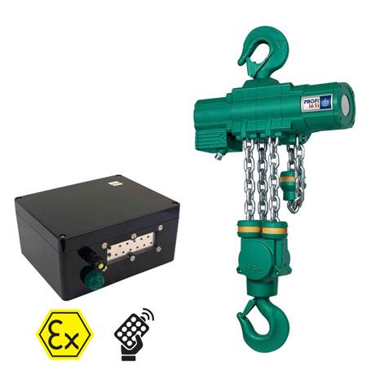
The latest radio control compact receiver which can be retro fitted on the J D Neuhaus Profi range of hoists and crane systems.
Download high resolution 300dpi image (2100 x 2100 px)
Download low resolution 72dpi image 700 x 700 px)

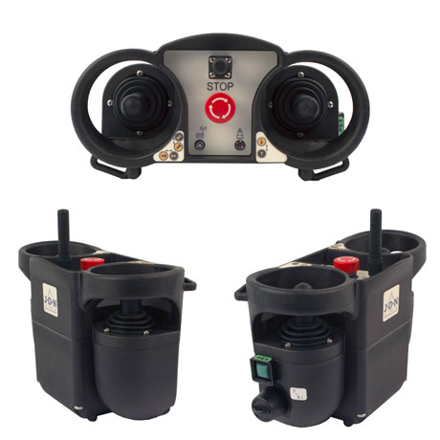
Control elements supplied with the latest RC equipment now available for the
J D Neuhaus range of handling equipment, and suitable for use in zone 2/22 conditions.
Download high resolution 300dpi image (2100 x 2100 px)
Download low resolution 72dpi image (700 x 700 px)
Continued ……
Company information

J D Neuhaus are a privately-owned company, founded in 1745, and for over 270 years they have been using their expertise and experience to manufacture the highest quality hoists and cranes.

Their products offer solutions to almost every material handling problem irrespective of the driving medium: from air and hydraulic hoists up to complete crane installations with explosion proofness.

JDN products are used in a wide variety of industries including:
Airplane Yards; Atomic/Coal Power Stations; Big Bag Handling; Cement Industry; Chemical Industry;
Crane Manufacturers; Dairies; Food Industry; Foundries; Galvanization; Glass/Ceramics; Large Kitchens;
Leather Plants; Locks; Machine and Plant Construction; Mining; Motor Car Industry; Offshore/Onshore;
Oil Storage; Over/Underground Construction; Paints and Varnish; Painting and Coating Installations;
Paper Industry; Pharmaceutical Industry; Printing Industry; Pyrotechnics Industries; Refineries; Sawmills; Shipbuilding and Shiprepair Yards; Ships; Space Technique; Spray Booths; Steel Works; Surface Technique;
Tank Cleaning Devices; Textile Industry; Tunnel; Tire Manufacturers; Vacuum Technique

Contact J D Neuhaus

J D Neuhaus are represented in more than 90 countries and over 70 branches Worldwide.

Germany
J D Neuhaus GmbH & Co. KG, 58449, Witten-Heven, Germany
Tel: +49 2302 208-219 Fax: +49 2302 208-286
e-mail: info@jdngroup.com www.jdngroup.com

France
J D Neuhaus S.A.R.L., 24, rue du Président Krüger, 69008, Lyon, France
Tel: +33 4 3790-1745 Fax: +33 4 3790-1746
e-mail: info@jdneuhaus.fr www.jdngroup.com

Great Britain
J D Neuhaus Ltd, Unit 6 Kirkton Avenue, Pitmedden Road Industrial Estate, Dyce, Aberdeen, AB21 0BF, UK
Tel: +44 1224 722751 Fax: +44 1224 729895
e-mail: info@jdneuhaus.co.uk www.jdngroup.com

Singapore
J.D. Neuhaus Pte. Ltd, 21 Toh Guan Road East, #09-02 Toh Guan Centre, 608609, Singapore
Tel: +65 62758911 Fax: +65 62758922
e-mail: info@jdn.com.sg www.jdngroup.com

USA
J.D. Neuhaus L.P., 9 Loveton Circle, MD 21152 Sparks, USA
Tel: +1-410 472-0500 Fax: +1-410 472-2202
e-mail: info@jdneuhaus.com www.jdngroup.com

